2 Bipolar Junction Transistors

2.1 Introduction
- Popular belief holds that the bipolar junction transistor (BJT) was developed by Schockley, Brattain, and Bardeen from Bell labs in 1948.
- This is not true, as the device invented was the point-contact transistor.
- BJTs were actually developed in the late 1951’s by Dr. Schockley.
- The transistor is a three-terminal device whose output current, voltage and/or power are controlled by its input current.
- Used primarily in communication as an amplifier to increase the strength of an ac signal.
- In digital systems it is primarily used as a switch.

Transistor Structure
- The BJT is constructed with three doped semiconductor regions separated by two pn junctions.
- The three regions are called emitter, base, and collector.
- There are two types of BJTs, either pnp (two p regions separated by one n region) and npn (two n regions separated by one p region).

- The C, B, and E symbols represent the common, emitter, and base regions, respectively.
- The base region is lightly doped and very thin compared to the heavily doped emitter and moderately doped collector regions.
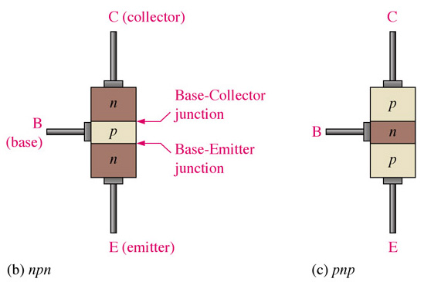

Basic Transistor Operation

- For correct operation, the two pn junctions must be correctly biased with external dc voltages.
- Operation of the pnp is similar as that of npn, but the roles of electrons and holes, bias polarities, and current directions are all reversed.
- The figure below shows the correct biasing of a BJT.
- Note the base-emitter (BE) junction is forward biased and the base-collector (BC) junction is reverse biased.
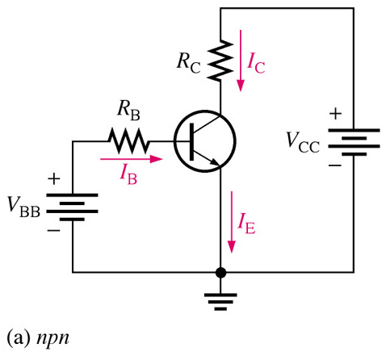

- The forward bias from base to emitter narrows the BE depletion region.
- The reverse bias from base to collector widens the BC depletion region.
- The heavily doped n-type emitter region is packed with conduction-band (free) electrons.
- The free electrons from the emitter diffuse easily through the forward biased BE junction into the p-type base region
- In the base, the electrons become minority carriers (like in a forward biased diode).
- The base region is lightly doped and very thin, so it has a limited number of holes.
- Because of that light doping, only a small percentage of all the electrons flowing through the BE junction can combine with the available holes in the base.
- These relatively few recombined electrons flow out of the base lead as valence electrons, forming the small base electron current.
- Most of the electrons flowing from the emitter into the lightly doped base region do not recombine, but diffuse into the BC depletion region.
- Once here, they are pulled through the reverse-biased BC junction by the electric field set up by the force of attraction between the positive and negative ions.
- Electrons now move through the collector region, out through the collector lead, and into the positive terminal of the collector voltage source.
- This forms the collector electron current. The collector current is much larger than the base current.
- This is the reason transistors exhibit current gain.
- From graph above:
I_{E} = I_{C} + I_{B}

- Capital letters indicate dc values.

Transistor Characteristics and Parameters
- The ratio of the dc collector current (I_{C}) to the dc base current (I_{B}) is the dc beta (β_{DC}).
- _{DC} is called the gain of a transistor:
β_{DC} = I_{C}/I_{B}

- Typical values of β_{DC} range from less than 20 to 200 or higher.
- β_{DC} is usually designated as an equivalent hybrid (h) parameter:
h_{FE} = β_{DC}

- The ratio of the collector current (I_{C}) to the dc emitter current (I_{E}) is the dc alpha (α_{DC}). This is a less-used parameter than beta.
α_{DC} = I_{C}/I_{E}

- Typical values range from 0.95 to 0.99 or greater.
- α_{DC} is always less than 1.
- This is because I_{C} is always slightly less than I_{E} by the amount of I_{B}.
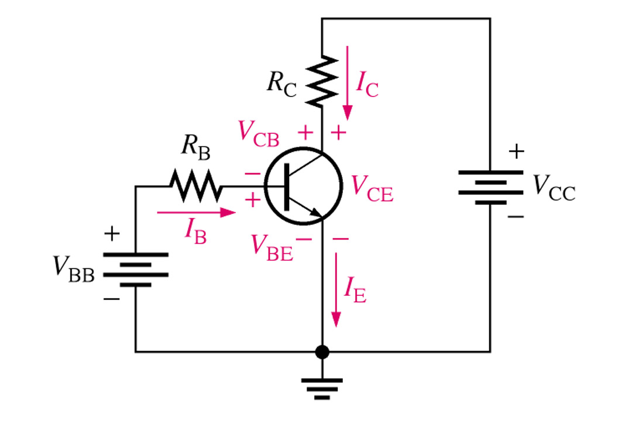

- From graph above we can see that there are 6 important parameters to be considered:

- I_{B}: dc base current.
- I_{E}: dc emitter current.
- I_{C}: dc collector current.
- V_{BE}:dc voltage at base with respect to emitter.
- V_{CB}: dc voltage at collector with respect to base.
- V_{CE}: dc voltage at collector with respect to emitter.

- V_{BB} forward-biases the BE junction.
- V_{CC} reverse-biases the BC junction.
- When the BE junction is forward biased, it is like a forward biased diode:
V_{BE} ≈ 0.7 V
- But it can be as high as 0.9 V (and is dependent on current). We will use 0.7 V from now on.
- Emitter is at ground. Thus the voltage across R_{B} is
V_{R(B)} = V_{BB}- V_{BE}

- Also:
V_{R(B)} = I_{R}R_{B}

- Or:
I_{R}R_{B} = V_{BB}- V_{BE}

- Solving:
I_{B} = (V_{BB}- V_{BE})/R_{B}

- Voltage at collector with respect to grounded emitter is:
V_{CE} = V_{CC} – V_{R(C)}

- Since drop across R_{C} is V_{R(C)} = I_{C}R_{C} the voltage at the collector is also:
V_{CE} = V_{CC} - I_{C}R_{C}

- Where I_{C} = β_{DC} I_{B}. Voltage across the reverse-biased collector-bias junction is
V_{CB} = V_{CE} - V_{BE}
Example:
Determine I_{B}, I_{C}, I_{E}, V_{BE}, V_{CE}, and V_{CB} in the following circuit. The transistor has β_{DC} 150.
Solution:
We know V_{BE}=0.7 V. Using the already known equations:
I_{B} = (V_{BB}- V_{BE})/R_{B}
I_{B} = (5 – 0.7)/10kΩ = 430 mA
I_{C} = β_{DC} I_{B} = (150)( 430 mA) = 64.5 mA
I_{E} = I_{C} + I_{B} = 64.5 mA + 430 mA = 64.9 mA
Solving for V_{CE} and V_{CB}:
V_{CE} = V_{CC} – I_{C}R_{C} = 10V-(64.5mA)(100 Ω) = 3.55 V
V_{CB} = V_{CE} – V_{BE} = 3.55 V – 0.7 V = 2.85 V
Since the collector is at higher potential than the base, the collector-base junction is reverse-biased.

- Changing the voltage supplies with variable voltage supplies in the circuit above, we can get the characteristic curves of the BJT.
- If we start at some positive V_{BB} and V_{CC} = 0 V, the BE junction and the BC junction are forward biased.
- In this case the base current is through the BE junction because of the low impedance path to ground, thus I_{C} is zero.
- When both junctions are forward-biased, the transistor is in the saturation region of operation.
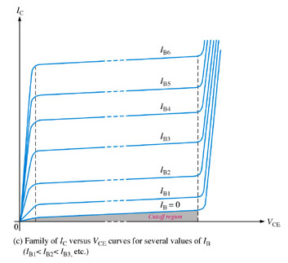

Output characteristic
Curve ( Ic verses VCE
For several values of IB )

- As V_{CC} is increase, V_{CE} gradually increases, as the I_{C} increases (This is the steep slope linear region before the small-slope region).
- I_{C} increases as V_{CC} increase because V_{CE} remains less than 0.7 V due to the forward-biased base-collector junction.
- Ideally, when V_{CE} exceeds 0.7 V, the BC junction becomes reverse biased.
- Then, the transistor goes into the linear region of operation.
- When the BC junction is reverse-biased, I_{C} levels off and remains essentially constant for a given value of I_{B} as V_{CE} continues to increase.
- Actually, there is a slight increase in I_{C}, due to the widening of the BC collector depletion region, which results in fewer holes for recombination in the base, which causes a slight increase in α_{DC}
- For the linear portion, the value of I_{C} is calculated by:
I_{C} = β_{DC} I_{B}
- When V_{CE} reaches a sufficiently large voltage, the reverse biased BC junction goes into breakdown.
- Thus, the collector current increases rapidly.
- A transistor should never be operated in this region.
- When I_{B} = 0, the transistor is in the cutoff region, although there is a small collector leakage current.
- Cutoff
- 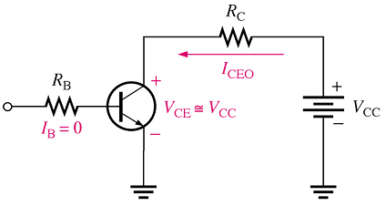As said before, when I_{B} = 0, transistor is in cutoff region.
- There is a small collector leakage current, I_{CEO}.
- Normally it is neglected so that V_{CE} = V_{CC}.
- In cutoff, both the base-emitter and the base-collector junctions are reverse-biased.
- Saturation
- 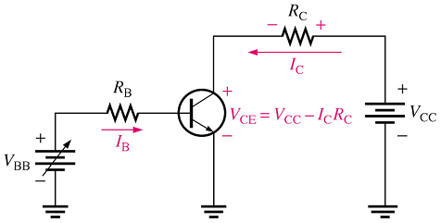When BE junction becomes forward biased and the base current is increased, I_{C} also increase (I_{C} – β_{DC}I_{B}) and V_{CE} decreases as a result of more drop across the collector resistor (V_{CE} = V_{CC} – I_{C}R_{C}).

- When V_{CE} reaches its saturation value, V_{CE(sat)}, the BC junction becomes forward-biased and I_{C} can increase no further even with a continued increase in I_{B}.

- At the point of saturation, I_{C} = β_{DC}I_{B} is no longer valid.
- V_{CE(sat)} for a transistor occurs somewhere below the knee of the collector curves.
- It is usually only a few tenths of a volt for silicon transistors.
- DC load line
- 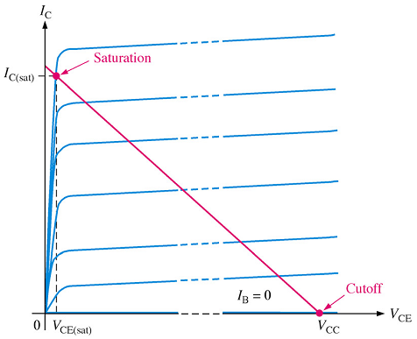Cutoff and saturation can be illustrated by the use of a load line.
- Bottom of load line is at ideal cutoff (I_{C} = 0 and V_{CE} = V_{CC}).
- Top of load line is at saturation (I_{C} = I_{C(sat)} and V_{CE} = V_{CE(sat)})
- In between cutoff and saturation along the load line is the active region.
- More to come later.

Example
Determine whether or not the transistor in circuit below is in saturation. Assume V_{CE(sat)} = 0.2 V.
First determine I_{C(sat)}.
I_{C(sat)} = (V_{CC} – V_{CE(sat)})/R_{C}
I_{C(sat)} =(10 V – 0.2V)/10k = 9.8 mA
Now let’s determine whether I_{B} is large enough to produce I_{C(sat)}.
I_{B} = (V_{BB} - V_{BE})/R_{B} = (3 V – 0.7 V)/10k = 0.23 mA
I_{C} = β_{DC} I_{B} = (50)(0.23 mA) = 11.5 mA
This shows that with the specified _{DC}, this base current is capable of producing an I_{C} greater than I_{C(sat)}. Thus, the transistor is saturated, and the collector current value of 11.5 mA is never reached. If you further increase I_{B}, the collector current remains at its saturation value.

- More on β_{DC}
- The β_{DC} of h_{FE} is not truly constant.
- It varies with collector current and with temperature.
- Keeping the junction temperature constant and increasing I_{C} causes β_{DC} to increase to a maximum.
- Further increase in I_{C} beyond this point causes β_{DC} to decrease.
- If I_{C} is held constant and temperature varies, β_{DC} changes directly with temperature.
- Transistor data specify β_{DC} at specific values. Normally the β_{DC} specified is the maximum value.

- Maximum transistor ratings
- Maximum ratings are given for collector-to-base voltage, collector-to-emitter voltage, emitter-to-base voltage, collector current, and power dissipation.
- The product V_{CE}I_{C} must not exceed P_{D(max)}.

Example:
The transistor shown in the figure below has the following maximum ratings: P_{D(max)}=800 mW, V_{CE(max)} = 15 V, and I_{C(max)} = 100 mA. Determine the maximum value to which V_{CC} can be adjusted without exceeding a rating. Which rating would be exceeded first?
Solution:
First, find I_{B}, so that you can determine I_{C}.
I_{B} = (V_{BB} – V_{BE})/R_{B} = (5 V – 0.7 V)/22 k = 195 mA
I_{C} = β_{DC} I_{B} = (100)(195 mA) = 19.5 mA

I_{C} is much less than I_{C(max)} and will not change with V_{CC}. It is determined only by I_{B} and β_{DC}.

The voltage drop across R_{C} is
V_{R(C)} =I_{C}R_{C} = (19.5 mA)(1 k) = 19.5 V

Now we can determine the value of V_{CC} when V_{CE} = V_{CE(max)} = 15 V.
V_{R(C)} = V_{CC} - V_{CE}

So,
V_{CC(max)} = V_{CE(max)} + V_{R(C)} = 15 V + 19.5V = 34.5 V

V_{CC} can be increased to 34.5 V, under the existing conditions, before V_{CE(max)} is exceeded. However, at this point it is not known whether or not P_{D(max)} has been exceeded:
P_{D} = V_{CE(max)}I_{C} = (15 V)(19.5 mA) = 293 mW

Since P_{D(max)} is 800 mW, it is not exceeded when V_{CC} = 34.5 V. So, V_{CE(max)} = 15 V is the limiting rating in this case. If the base current is removed, causing the transistor to turn off, V_{CE(max)} will be exceeded first because the entire supply voltage, V_{CC}, will be dropped across the transistor.

The Transistor as an Amplifier – An introduction
- Amplification is the process of linearly increasing the amplitude of an electrical signal.
- A transistor can act as an amplifier directly using the current gain factor , β_{DC}
- Keep in mind that when a transistor is biased in the active (linear) region, the BE junction has a low resistance due to forward bias and the BC junction has a high resistance due to reverse bias.
- DC and AC quantities
- Amplifier circuits have both ac and dc quantities.
- Capital letters are used will be used for both ac and dc currents.
- Subscript will be capital for dc quantities.
- Subscript will be lowercase for ac quantities.

- Transistor amplification
- A transistor amplifies current because the collector current is equal to the base current multiplied by the current gain, β_{DC} .
- Base current (I_{B}) is small compared to I_{C} and I_{E}.
- Thus, I_{C} is almost equal to I_{E}.
- Consider the following circuit.
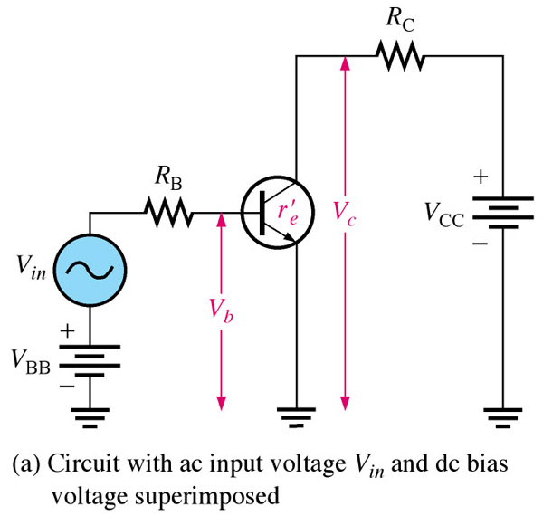

- An ac voltage, V_{in}, is superimposed on the dc bias voltage V_{BB.}
- DC bias voltage V_{CC} is connected to the collector through the collector resistance, R_{C}.
- The ac input voltage produces an ac base current, which results in a much larger ac collector current.
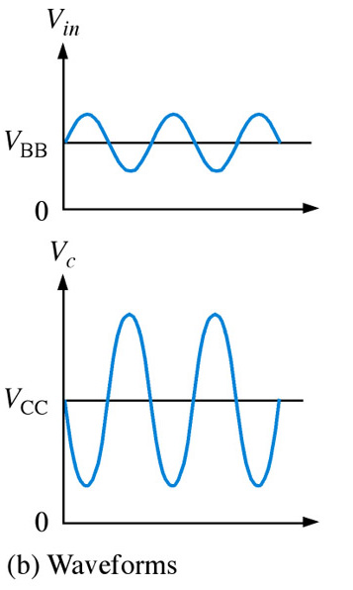
- The ac collector current produces an ac voltage across R_{C}, thus producing an amplified, but inverted, reproduction of the ac input voltage in the active region.

- The forward biased base-emitter junction present low resistance to the ac wave.
- This internal ac emitter resistance is designated r’_{e}.
I_{e} ≈ I_{c} = V_{b}/ r’_{e}

- The ac collector voltage, V_{c} = I_{c}R_{C}.
- Since I_{e} ≈ I_{c}, the ac collector voltage is V_{c} ≈ I_{e}R_{C}.
- V_{b} can be considered the transistor ac input voltage where V_{b} = V_{in} – I_{b}R_{B}.
- V_{c} can be considered the transistor ac output voltage.
- The ratio of V_{c} to V_{b} is the ac voltage gain, A_{v}, of the transistor circuit.
A_{v} = V_{c}/V_{b}
- Substituting I_{e}R_{C} for V_{c} and I_{e} r’_{e} for V_{b} yields
A_{v} = V_{c}/V_{b} ≈ (I_{e}R_{C})/(I_{e} r’_{e}) = R_{C}/ r’_{e}
- Thus, amplification depends on the ratio of R_{C} and r’_{e}.
- R_{C} is always considerably larger in value than r’_{e}, thus the output voltage is larger than the input voltage.

Example:
Determine the voltage gain and the ac output voltage for the following circuit if r’_{e} = 50 Ω.
Solution:
The voltage gain is
A_{v} ≈ R_{C}/r’_{e} = 1 k Ω /50 Ω = 20
Thus the output voltage is
V_{out} = A_{v}V_{b} = (20)(100 mV) = 2 V_{rms}

The Transistor as a Switch
- One major application of a transistor is as an amplifier.
- The other major application is switching applications.
- In this case, it is operated alternately in cutoff and saturation.
- 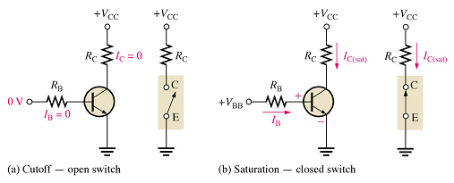Analyze the following Fig .

- In (a), the device is in the cutoff region because the base-emitter junction is not forward biased.
- In this condition there is, ideally, an open between collector and emitter.
- In (b), the transistor is in the saturation region because the base-emitter junction and the base-collector junction are forward-biased and the base current is made large enough to reach its saturation point.
- In this condition there is, ideally, a short between collector and emitter.
- Actually, a drop of up to a few tenths of a volt normally occurs.

- Conditions in cutoff
- A transistor is in cutoff region when the BE junction is NOT forward biased.
- Neglecting leakage current, all currents are zero and V_{CE} = V_{CC.}
- Conditions in saturation
- When the BE junction is forward biased and there is enough base current to produce a maximum collector current, transistor is saturated.
I_{C(sat)} = (V_{CC} – V_{CE(max)})/R_{C}
- Minimum value of base current needed to produce saturation is
I_{B(min)} = I_{C(sat)}/ β_{DC}
Example:
Consider the following circuit.
The LED requires 30 mA to emit a sufficient level of light. Therefore the collector current should be approximately 30 mA. For the following circuit values, determine the amplitude of the square wave input voltage necessary to make sure that the transistor saturates. Use double the minimum value of base current as a safety margin to ensure saturation. V_{CC} = 9 V, V_{CE(sat)} = 0.3 V, R_{C} = 270 Ω , R_{B} =3.3 k Ω, and β_{DC} = 50.

Solution:
When the square wave is at 0 V, the transistor is in cutoff and, since there is no collector current, the LED does not emit light. When the square wave goes to its high level, the transistor saturates. This forward-biases the LED, and the resulting collector current through the LED causes is to emit light.

I_{C(sat)} = (V_{CC} – V_{CE(sat)})/R_{C} = (9 V – 0.3 V)/270 Ω = 32.2 mA
I_{B(min)} = I_{C(sat)}/  β_{DC} = 32.2 mA/50 = 644 mA

To ensure saturation, use twice the value of I_{B(min)}, that is, 1.29 mA. Then

I_{B} = V_{R(B)}/R_{B} = (V_{in} – V_{BE})/R_{B} = (V_{in} – 0.7)/3.3k Ω

Solving for the voltage amplitude of the square wave input, V_{in}, we get:
V_{in} – 0.7 = 2 I_{B(min)}R_{B} = (1.29 mA)(3.3 k Ω)
V_{in} = (1.29 mA)(3.3 k kΩ) + 0.7 V = 4.96 V

Chapter Summary
- BJTs have three regions: base, collector, and emitter.
- BJTs have two pn junctions: base-emitter, and base-collector.
- Current in a BJT consists of both free electrons and holes, thus the term bipolar.
- Base is lightly doped compared to emitter and collector.
- There are two types of BJTs: npn and pnp.
- To operate as amplifier, the BE junction must be forward-biased and BC junction must be reverse-biased (forward-reverse bias).
- I_{B} is very small compared to I_{C} and I_{E}.
- The dc current gain is β_{DC} = I_{C}/I_{B}.
- When a BJT is forward-reverse biased, the voltage gain depends on the internal emitter resistance and the external collector resistance.
- A transistor can be operated as a switch in cutoff and saturation.
- In cutoff, both pn junctions are reverse-biased. Thus no I_{C}. Therefore, there is an open between collector and emitter.
- In saturation, both pn junctions are forward-biased and the collector current is maximum. Behaves like a closed switch between collector and emitter.

