[1] Ideal Operational Amplifier

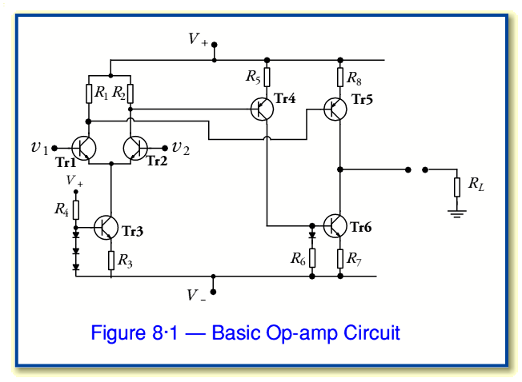

Ideal Operational Amplifier
The Operational Amplifier, or Op-amp as it is more commonly called, is one of the basic building blocks of Analogue Electronic Circuits. It is a linear device that has all the properties required for nearly ideal d.c. amplification and is used extensively in signal conditioning, filtering or to perform mathematical operations such as add, subtract, integration and differentiation. An Operational Amplifier is a 3-terminal device that consists basically of two high impedance inputs, one an Inverting input marked with a negative sign, ("-") and the other a Non-inverting input marked with a positive plus sign ("+"). An ideal Operational Amplifier also has a Low Output Impedance that is referenced to a common ground terminal. They can also operate from either a single or a dual (±) power supply.
An Operational Amplifier on its own has a very high open-loop d.c. gain and by applying some form of negative feedback we can produce an amplifier circuit that has a very precise gain characteristic. An operational amplifier only responds to the difference between the voltages on its two input terminals, known commonly as the Differential Input Voltage and not to their common potential. Thus, the gain of the Op-amp is known as the Open Loop Differential Gain, and is given the symbol (A_{o}).

An Ideal Operational Amplifier including its Idealized Characteristics.
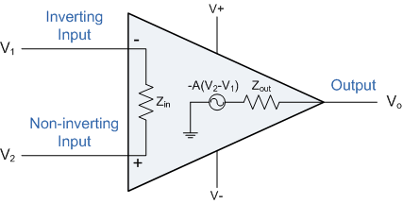

PARAMETER | IDEALIZED CHARACTERISTIC
Voltage Gain, (A) | Infinite - The main function of an operational amplifier is to amplify the input signal and the more open loop gain it has the better, so for an ideal amplifier the gain will be infinite.
Input Impedance, (Z_{in}) | Infinite - Input impedance is assumed to be infinite to prevent any current flowing from the source supply into the amplifiers input circuitry.
Output Impedance, (Z_{out}) | Zero - The output impedance of the ideal operational amplifier is assumed to be zero so that it can supply as much current as necessary to the load.
Bandwidth, (BW) | Infinite - An ideal operational amplifier has an infinite Frequency Response and can amplify any frequency signal so it is assumed to have an infinite bandwidth.
Offset Voltage, (V_{io}) | Zero - The amplifiers output will be zero when the voltage difference between the inverting and non-inverting inputs is zero.
From these "idealized" characteristics above, we can see that the input resistance is infinite, so no current flows into either input terminal (the current rule) and that the differential input offset voltage is zero (the voltage rule). It is important to remember these two properties as they help understand the workings of the circuit with regards to analysis and design of operational amplifier circuits.
However, real op-amps such as the uA741, for example do not have infinite gain or bandwidth but have a typical "Open Loop Gain" which is defined as the amplifiers output amplification without any external feedback signals connected to it and for a typical operational amplifier is about 100dB at d.c. (zero Hz). This output gain decreases linearly with frequency down to "Unity Gain" or 1, at about 1MHz and this is shown in the following open loop gain response curve.

Open-loop Frequency Response Curve
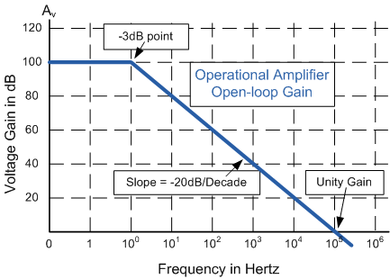
From this frequency response curve we can see that the product of the gain against frequency is constant at any point along the curve. Also that the unity gain (0dB) frequency also determines the gain of the amplifier at any point along the curve. This constant is generally known as the Gain Bandwidth Product or GBP.
Therefore, GBP = Gain x Bandwidth or A x BW.
For example, from the graph above the gain of the amplifier at 100kHz = 20dB or 10, then the
GBP = 100,000Hz x 10 = 1,000,000.
Similarly, a gain at 1kHz = 60dB or 1000, therefore the
GBP = 1,000 x 1,000 = 1,000,000. The same!.
The Voltage Gain (A) of the amplifier can be found using the following formula:
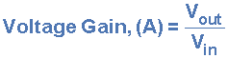
and in Decibels or (dB) is given as:


Operational Amplifier Bandwidth
The bandwidth of an operational amplifier is the frequency range over which the voltage gain of the amplifier is above 70.7% or -3dB (where 0dB is the maximum) of its maximum output value as shown below.
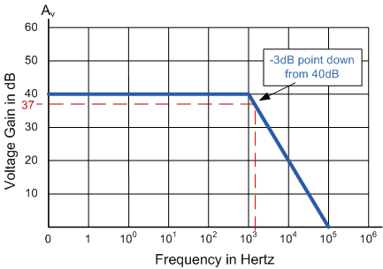
Here we have used the 40dB line as an example. The -3dB or 70.7% of Vmax down point from the frequency response curve is given as 37dB. Taking a line across until it intersects with the main GBP curve gives us a frequency point just above the 10kHz line at about 12 to 15kHz. We can now calculate this more accurately as we already know the GBP of the amplifier, in this particular case 1MHz.

Example No1.
Using the formula 20 log (A), we can calculate the bandwidth of the amplifier as:
37 = 20 log A therefore, A = anti-log (37 ÷ 20) = 70.8
GBP ÷ A = Bandwidth, therefore, 1,000,000 ÷ 70.8 = 14,124Hz, or 14 kHz
Then the bandwidth of the amplifier at a gain of 40dB is given as 14 kHz as previously predicted from the graph.

Example No2.
If the gain of the amplifier was reduced by half to say 20dB in the above frequency response curve, the -3dB point would now be at 17dB. This would then give us an overall gain of 7.08, therefore A = 7.08. If we use the same formula as above this new gain would give us a bandwidth of 141.2 kHz, ten times more than at 40dB. It can therefore be seen that by reducing the overall open loop gain of an operational amplifier its bandwidth is increased and visa versa. The -3dB point is also known as the "half power point", as the output power of the amplifier is at half its maximum value at this point.

Op-amp types
Operational amplifiers can be connected using external resistors or capacitors in a number of different ways to form basic "building Block" circuits such as, Inverting, Non-Inverting, Voltage Follower, Summing, Differential, Integrator and Differentiator type amplifiers. There are a very large number of operational amplifier i,c's available to suit every possible application such as bipolar standard, precision, high-speed, low-noise, high-voltage, etc and again with internal JFET transistors.
The most commonly available and used of all operational amplifiers is the industry standard μA-741.

Inverting Amplifier
We saw in the last section that the Open Loop Gain of an operational amplifier can be very high upto about 1,000,000 (120dB). However, this very high gain is of no real use as it makes the amplifier both unstable and hard to control as the smallest of input signals, only a few microvolt’s, would be enough to cause the output to saturate and swing towards one or the other of the supply rails. As the D.C. gain of the amplifier is so high we can afford to loose some by connecting a resistor from the output back to the inverting input to control the gain of the amplifier. This then produces and effect known commonly as Negative Feedback, thus producing a very stable operational amplifier system.
Negative Feedback is the process of feeding some of the output signal back to the input, but to make the feedback negative we must feed it back to the "Negative input" using a Feedback Resistor called Rf. The negative input will now have a different signal on it than the actual input voltage as it will be the sum of the input voltage and the negative feedback voltage. We must therefore separate the real input signal from the inverting input by using an Input resistor Rin. As we are not using the positive non-inverting input this is connected to the ground terminal as shown below.

Inverting Amplifier Circuit
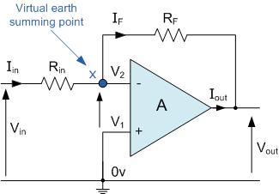 | In this Inverting Op-amp circuit the amplifier is connected with feedback to produce a closed loop operation. There are two very important rules to remember about operational amplifiers is that, "no current flows into the input" and that "V1 equals V2". This is because the junction of the input and feedback signal (X) is at the same potential as the positive (+) input which is at zero volts or ground then, the junction is a "Virtual Earth" summing point. Because of this virtual earth node the input resistance of the amplifier is equal to the value of the input resistor, Rin.
Using these two rules we can now find the equation for calculating the gain of the amplifier, using first principles.
Current (i) flows through the resistor network as shown.
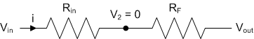
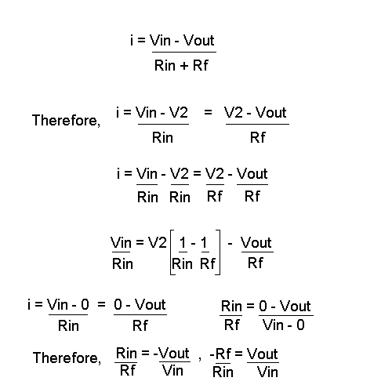
Then, the Voltage Gain of the amplifier is determined from the following formula.
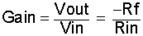
and


Example No1
Find the gain of the following amplifier circuit.
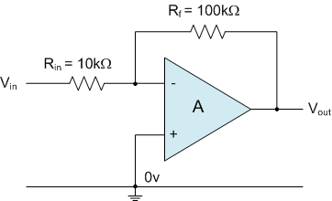
Using the previously formula for the gain of the circuit
we can now substitute the values of the resistors as follows,
Rin = 10kΩ and Rf = 100kΩ.
then the gain of the circuit is given as -Rf/Rin = 100k/10k = 10.
therefore, the gain of the circuit is 10 or 20dB.

Example No2.
The gain of the circuit is to be increased to 40, find the new values of the resistors required.
Assume that the input resistor is to remain the same value at 10KΩ, then by re-arranging the voltage gain formula we can find the new value of the feedback resistor Rf.
Gain = -Rf/Rin
therefore, Rf = Gain x Rin
Rf = 40 x 10,000
Rf = 400,000 or 400KΩ
The new values of resistors required for the circuit to have a gain of 40 would be,
Rin = 10KΩ and Rf = 400KΩ.
The formula could also be rearranged to give a new value of Rin, keeping the same value of Rf.

Non-Inverting Amplifier
The second basic configuration of an operational amplifier is that of a Non-inverting Amplifier. In this circuit the input voltage signal is applied directly to the Non-inverting (+) input which means that the gain of the amplifier is positive. Feedback is achieved by applying a small part of the output voltage signal to the inverting (-) input via the Rf - Rin voltage divider network as shown below.

Non-inverting Operational Amplifier
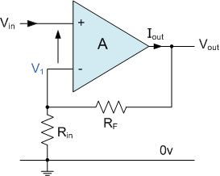
In the previous Inverting Amplifier page we saw that "no current flows into the input" of the amplifier and that "V1 equals V2". This was because the junction of the input and feedback signal (V1) are at the same potential in other words the junction is a "Virtual Earth" summing point. Because of this virtual earth node the resistors, Rf and Rin form a simple voltage divider network as shown below.

Equivalent Voltage Divider Network
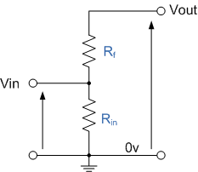
and the Gain of this circuit can be calculated as:
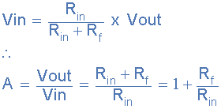
Then the Closed loop gain of a Non-inverting Operational Amplifier is given as:
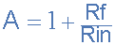
We can see that the overall gain of a Non-inverting op-amp is greater but never less than 1 (unity), is positive and is determined by the ratio of the values of Rf and Rin.

Voltage Follower (Unity Gain Buffer)
If we made the feedback resistor, Rf = 0 then the circuit would be classed as a Voltage Follower and the gain would be fixed at 1. This type of non-inverting amplifier circuit is sometimes called a Voltage follower with gain. As the input signal is connected directly to the non-inverting input of the amplifier the output signal is not inverted making it ideal as a Unity Gain Buffer circuit because of its isolation properties. The input impedance of the circuit is very high, typically above 1MΩ as it is equal to that of the op-amp input, since an ideal op-amp condition is assumed.
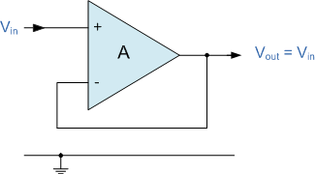
In this circuit, Rin has increased to infinity and Rf reduced to zero, the feedback is 100% and Vout is exactly equal to Vin giving it a fixed gain of 1 or unity. As the input voltage Vin is applied to the non-inverting input the gain of the amplifier is given as:
and can also be written as:
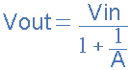
Since no current flows into the non-inverting input terminal the input impedance is infinite and also no current flows through the feedback loop so any value of resistance may be placed in the feedback loop without affecting the characteristics of the circuit as no voltage is dissipated across it, zero current, zero voltage, zero power drop.
The voltage follower or unity buffer is a special and very useful type of non-inverting operational amplifier circuit that is commonly used in electronics to isolated circuits from each other and typical i.c.'s available are the 74LS125 Quad 3-state buffer or the more common 74LS244 Octal buffer.
One final thought, the voltage gain of the voltage follower circuit with closed loop gain is Unity, the voltage gain of an ideal operational amplifier with open loop gain is Infinite. Then by carefully selecting the feedback components we can control the amount of gain produced by the amplifier from 1 to infinity.
Summing Op-amp | Navigation
Page: 4 of 8

Summing Amplifier
The basic Inverting operational amplifier configuration is a very flexible circuit. If we add another input resistor equal to the value of the original input resistor, Rin we end up with another operational amplifier circuit called a Summing Amplifier, "Summing Inverter" or even "Voltage Adder" circuit as shown below.

Summing Amplifier Circuit
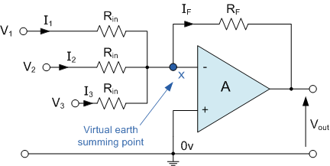
We can modify the original equation for the inverting amplifier to take account of these new inputs thus:
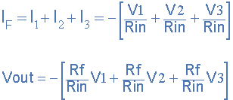
Therefore, if all the input impedances are equal the final equation is given as:

We now have an operational amplifier circuit that will amplify each individual input voltage and produce an output signal that is proportional to the algebraic "SUM" of the three input voltages V₁, V₂ and V₃. We can also add more inputs if required as each individual input "see's" their respective resistance, Rin as the only input impedance. This is because the input signals are isolated from each other by the "virtual earth" node at the inverting input of the op-amp. A direct voltage addition can also be obtained when all the resistances are of equal value, Rf is equal to Rin.
A Scaling Summing Amplifier can be made if the individual input resistors are NOT equal. Then the equation would have to be modified to:

We can also rearrange the formula to make the feedback resistor R_{f} the subject and the output voltage is found from

Allowing the output voltage to be easily calculated if more input resistors are connected to the amplifiers input. The input impedance of each individual channel is the value of their respective input resistors, ie, R₁, R₂, R₃ ... etc.
The Summing Operational Amplifier is a very flexible circuit indeed, enabling us to effectively "Add" or "Sum" together several individual input signals. If the input resistors, R₁, R₂, R₃ etc, are all equal a unity gain inverting adder can be made. However, if the input resistors are of different values a "scaling summing amplifier" is produced which gives a weighted sum of the input signals.
If the input resistances are also connected to potentiometers the input signals can be mixed together by varying amounts. For example, measuring temperature, you could add a negative offset voltage to make the display read "0" at the freezing point or produce an audio mixer for adding or mixing together individual waveforms (sounds) from different source channels (vocals, instruments, etc) before sending them combined to an audio amplifier.

Audio Mixer Amplifier
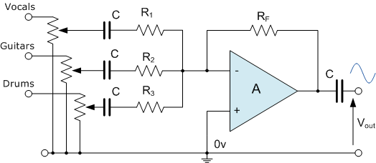
Differential Op-amp | Navigation
Page: 5 of 8

Differential Amplifier
Up to now we have used only one input to connect to the amplifier, using either the "Inverting" or "Non-inverting" input terminal to amplify a single input signal with the other input being connected to ground. But we can also connect signals to both of the inputs at the same time producing another common type of operational amplifier circuit. By connecting one voltage signal onto one input terminal and another voltage signal onto the other input terminal the resultant output voltage will be proportional to the "Difference" between the two input signals of V1 and V2. This type of circuit can also be used as a Subtractor.
Then, this type of Operational Amplifier circuit is commonly known as a Differential Amplifier configuration and is shown below:

Differential Operational Amplifier
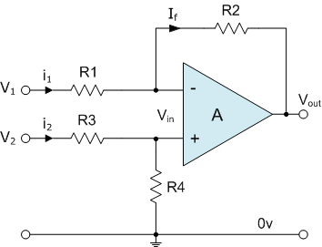
Then the transfer function for a Differential Amplifier circuit is given as:
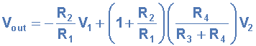
When R1 = R3 and R2 = R4 the transfer function formula can be modified to:
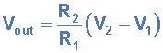
If all the resistors are all of the same ohmic value the circuit will become a Unity Gain Differential Amplifier, or Subtractor and the gain of the amplifier will be 1 or Unity.
The Op-amp Differential Amplifier circuit is very useful op-amp circuit and by adding more resistors in parallel with both R1 and R3 the resultant circuit can be made to either "Add" or "Subtract" the voltages applied to their respective inputs. It can also be used as a differential voltage comparator by "Comparing" one input voltage to the other. For example, by connecting one input to a fixed voltage reference and the other to either a "Thermistor" or a "Light Dependant Resistor" the amplifier circuit can be used to detect either low or high levels of temperature or light as shown below.

Light Activated Switch
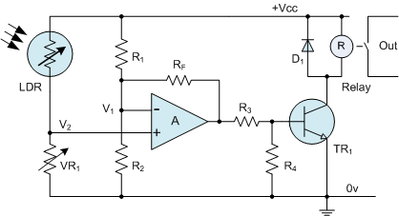
Here the circuit above acts as a light-activated switch which turns the output relay either "ON" or "OFF" as the light level detected by the LDR resistor exceeds or falls below the pre-set value of VR1. The fixed voltage reference is applied to the inverting input terminal V1 via the R1 - R2 voltage divider network and the variable voltage (proportional to the light level) applied to the non-inverting input terminal V2. It is also possible to detect temperature using this type of circuit by simply replacing the Light Dependant Resistor (LDR) with a thermistor.
One major limitation of this type of amplifier design is that its input impedances are lower compared to that of other operational amplifier configurations, for example, a non-inverting (single-ended input) amplifier. Each input voltage source has to drive current through an input resistance, which has less overall impedance than that of the op-amps input alone. One way to overcome this problem is to add a Unity Gain Buffer Amplifier such as the voltage follower seen in the previous section to each input resistor. This then gives us a differential amplifier circuit with very high input impedance and is the basis of most "Instrumentation Amplifiers".

Instrumentation Amplifier
Instrumentation Amplifiers are high gain differential amplifiers with high input impeadance and a single ended output. They are mainly used to amplify very small differential signals from strain guages, thermocouples or current sensing resistors in motor control systems. They also have very good common mode rejection (zero output when V1 = V2) in excess of 100dB at D.C. A typical example of an instrumentation amplifier with a high input impedance (Zin) is given below:

High Input Impedance Instrumentation Amplifier
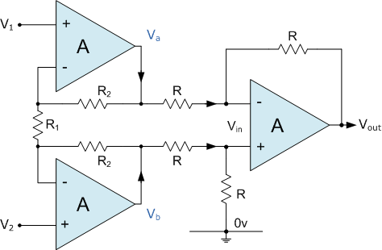
The negative feedback of the top op-amp causes the voltage at Va to be equal to the input voltage V1. Likewise, the voltage at Vb is equal to the value of V2. This produces a voltage drop across R1 which is equal to the voltage difference between V1 and V2. This voltage drop causes a current to flow through R1, and as the two inputs of the buffer op-amps draw no current (virtual earth), the same amount of current flowing through R1 must also be flowing through the two resistors R2. This then produces a voltage drop between points Va and Vb equal to:
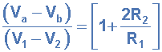
This voltage drop between points Va and Vb is connected to the inputs of the differential amplifier which amplifies it by a gain of 1 (assuming that all the "R" resistors are of equal value). Then we have a general expression for overall voltage gain of the instrumentation amplifier circuit as:
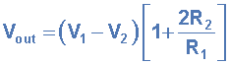
The differential gain of the circuit can be changed by changing the value of R1.
  Integrator Op-amp
  Navigation
  Page: 6 of 8
  The Integrator
  In the previous sections we have seen circuits which show how an operational amplifier can be used as part of a positive or negative feedback amplifier or adder, subtractor type circuit using just resistors in the input and the feedback loop. But what if we change the Resistive (Rf) feedback element of an inverting amplifier to that of a Frequency Dependant Impeadance (Z) element, such as a Capacitor. We now have a resistor and capacitor forming an RC Network across the operational amplifier as shown below.
  Integrator Amplifier Circuit
  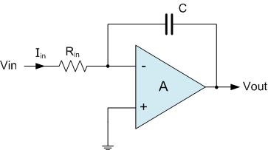
  As its name implies, the Integrator Operational Amplifier is a circuit that performs the mathematical operation of Integration, that is we can cause the output to respond to changes in the input voltage over time and the integrator produces a voltage output which is proportional to that of its input voltage and time. In other words the magnitude of the output signal is determined by the length of time a voltage is present at its input as the current through the feedback loop charges the capacitor.
  When a voltage, Vin is first applied to the input of an integrating amplifier, the uncharged capacitor C has very little resistance and acts a bit like a short circuit (voltage follower circuit) giving an overall gain of less than 1, thus resulting in zero output. As the feedback capacitor C begins to charge up, its reactance Xc decreases and the ratio of Zf/Rin increases producing an output voltage that continues to increase until the capacitor is fully charged. At his point the ratio of feedback capacitor to input resistor (Zf/Rin) is infinite resulting in infinite gain and the output of the amplifier goes into saturation as shown below. (Saturation is when the output voltage of the amplifier swings heavily to one voltage supply rail or the other with no control in between).
  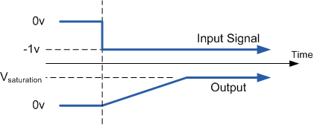
  The rate at which the output voltage increases is determined by the values of the resistor and the capacitor, "RC time constant". By changing this RC time constant value, either by changing the values of the capacitor, C or the resistor, R the time in which it takes the output voltage to reach saturation can be changed for example.
  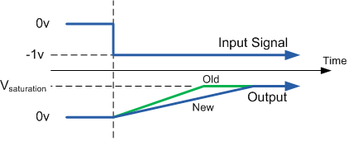
  If we apply a constantly changing input signal such as a square wave to the input of an Integrator amplifier then the capacitor will charge and discharge in response to changes in the input signal. This results in the output signal being that of a saw tooth waveform whose frequency is dependant upon the RC time constant of the resistor/capacitor combination. This type of circuit is also known as a Ramp Generator and the transfer function is given below.
  Ramp Generator
  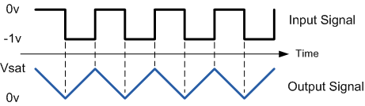
  Since the node voltage of the integrating op-amp at its inverting input terminal is zero, the current Iin flowing through the input resistor is given as:
  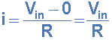
  The current flowing through the feedback capacitor C is given as:
  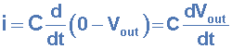
  Assuming that the input impeadance of the op-amp is infinite (ideal op-amp), no current flows into the op-amp terminal. Therefore, the nodal equation at the inverting input terminal is given as:
  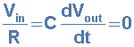
  From which we have an ideal voltage output of:
  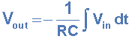
  This can also be re-written as:
  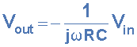
  Where jω = 2πƒ and the output voltage Vout is a constant 1/RC times the integral of the input voltage Vin with respect to time. The minus sign (-) indicates a 180⁰ phase shift because the input signal is connected directly to the inverting input terminal of the op-amp.
  The AC or Continuous Integrator
  If we changed the above square wave input signal to a sine wave of varying frequency the integrator amplifier begins to behave as a "Low Pass Filter", passing low frequency signals while attenuating high frequencies. However, at d.c. (0Hz) the capacitor acts as an open circuit resulting in zero negative feedback from the output to the input of the amplifier. Then the amplifier effectively is connected as an open-loop amplifier with very high open-loop gain resulting in the output voltage saturating.
  The addition of a large value resistor, R2 across the capacitor, C gives the circuit the characteristics of an inverting amplifier with finite closed-loop gain of Rf/Rin at very low frequencies while acting as an integrator at higher frequencies. This then forms the basis of a Active Low Pass Filter as seen before in the filters section.
  A.C. Integrator with d.c. Gain
  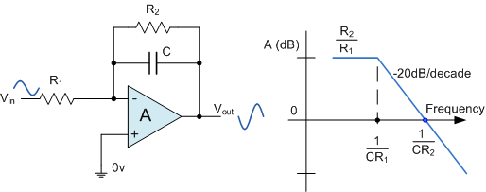
  Add this Page to
  your Favourites
  Advertisment
  The Differentiator
  The basic Differentiator Amplifier circuit is a the exact opposite to the Integrator operational amplifier circuit that we saw in the previous section. Here the position of the capacitor and resistor have been reversed and now the Capacitor, C is connected to the input terminal of the inverting amplifier while the Resistor, Rf forms the negative feedback element across the operational amplifier. This circuit preforms the mathematical operation of Differentiation, that is it produces a voltage output which is proportional to the input voltage´s rate-of-change and the current flowing through the capacitor. In other words the faster or larger the change to the input voltage signal, the greater the input current, the greater will be the output voltage change in response becoming more of a "spike" in shape.
  As with the integrator circuit, we have a resistor and capacitor forming an RC Network across the op-amp and the reactance (Xc) of the capacitor plays a major role in the performance of a Differentiator Amplifier.
  Differentiator Amplifier Circuit
  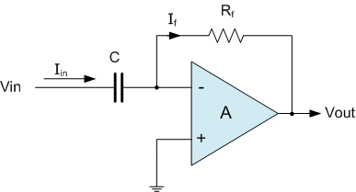
  The capacitor blocks any d.c. content only allowing a.c. type signals to pass through and whose frequency is dependant on the rate of change of the input signal. At low frequencies the reactance of the capacitor is "High" resulting in a low gain (Rf/Xc) and low output voltage from the op-amp. At higher frequencies the reactance of the capacitor is much lower resulting in a higher gain and higher output voltage from the op-amp.
  However, at high frequencies a differentator circuit becomes unstable and will start to oscillate. This is due mainly to the First-order effect which determines the frequency response of the op-amp circuit causes a Second-order response which, at high frequencies gives an output voltage far higher than what was expected. To avoid this the high frequency gain of the circuit needs to be reduced by adding an additional small value capacitor across the feedback resistor Rf.
  Since the node voltage of the operational amplifier at its inverting input terminal is zero, the current, i flowing through the capacitor is given as:
  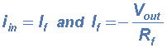
  The Charge on the Capacitor = Capacitance x Voltage across the Capacitor
  The rate of change of this charge is
  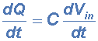
  but dQ/dt is the capacitor current i
  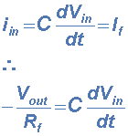
  From which we have an ideal voltage output of:
  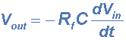
  Therefore, the output voltage Vout is a constant -Rf.C times the derivative of the input voltage Vin with respect to time. The minus sign indicates a 180⁰ phase shift because the input signal is connected to the inverting input terminal of the operational amplifier.
  One final point to mention, the Differentiator amplifier circuit in its basic form has two main disadvantages compared to the previous Integrator circuit. One is that it suffers from instability at high frequencies as mentioned above, and the other is that the capacitive input makes it very susceptible to random noise signals and any noise or harmonics present in the circuit will be amplified more than the input signal itself. This is because the output is proportional to the slope of the input voltage so some means of limiting the bandwidth in order to achieve closed-loop stability is required
  Differentiator Waveforms
  If we apply a constantly changing signal such as a Square wave, Triangular or Sine wave signal to the input of a differentiator amplifier circuit the resultant output signal will be changed and whose final shape is dependant upon the RC time constant of the Resistor/Capacitor combination.
  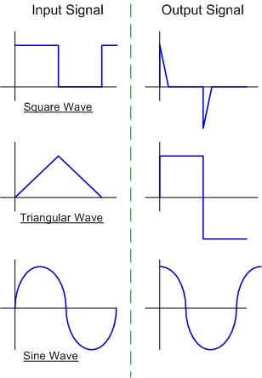
  Improved Differentiator Amplifier
  The basic single resistor and single capacitor differentiator circuit is not widely used to reform the mathematical function of Differentiation because of the two inherent faults mentioned above, Instability and Noise. So in order to reduce the overall closed-loop gain of the circuit at high frequencies, an extra Resistor, R2 is added to the input as shown below.
  Improved Differentiator Amplifier Circuit
  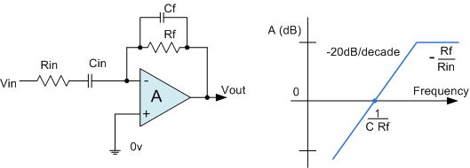
  The circuit which we have now acts like a Differentiator amplifier at low frequencies and an amplifier with resistive feedback at high frequencies giving much better noise rejection. This then forms the basis of a Active High Pass Filter as seen before in the filters section.
  Goto Page: | 1 | 2 | 3 | 4 | 5 | 6 | 7 | 8
  Add this Page to
  your Favourites
  Advertisment

Op-amps Section Summary
- The Operational Amplifier, or Op-amp as it is most commonly called, is an ideal amplifier with infinite Gain and Bandwidth when used in the Open-loop mode with typical d.c. gains of 100,000, or 100dB.
- The basic construction is of a 3-terminal device, 2-inputs and 1-output.
- An Operational Amplifier operates from a dual positive (+V) and an corresponding negative (-V) supply but they can also operate from a single DC supply voltage.
- It has Infinite Input Impeadance, (Z∞) resulting in "No current flowing into either of its two inputs" and zero input offset voltage "V1 = V2".
- It also has Zero Output Impeadance, (Z=0).
- Op-amps sense the difference between the voltage signals applied to the two input terminals and then multiply it by some pre-determined Gain, (A).
- This Gain, (A) is often referred to as the amplifiers "Open-loop Gain".
- Op-amps can be connected into two basic circuits, Inverting and Non-inverting.

The Two Basic Operational Amplifier Circuits
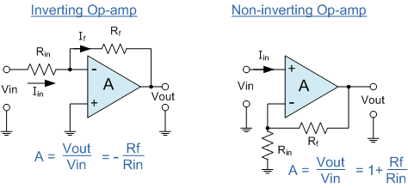
- The Open-loop gain called the Gain Bandwidth Product, or (GBP) can be very high and is a measure of how good an amplifier is.
- Very high GBP makes an Operational Amplifier circuit unstable as a microvolt input signal causes the output voltage to go into Saturation.
- By the use of suitable Feedback Resistor, (Rf) the overall gain of the amplifier can be accurately controlled.

Gain Bandwidth Product
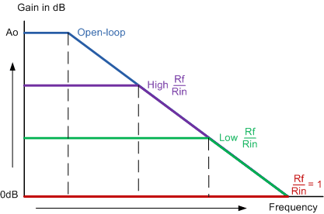
- For Negative feedback, where the fed-back voltage is in "Anti-phase" to the input the overall gain of the amplifier is reduced.
- For Positive feedback, where the fed-back voltage is in "Phase" with the input the overall gain of the amplifier is increased.
- By connecting the output directly back to the negative input terminal, 100% feedback is achieved resulting in a Voltage Follower (buffer) circuit with a constant gain of 1 (Unity).
- Changing the fixed feedback resistor (Rf) for a Potentiometer, the circuit will have Adjustable Gain.
- The Differential Amplifier produces an output that is proportional to the difference between the 2 input voltages.

Differential and Summing Op-amp Circuits
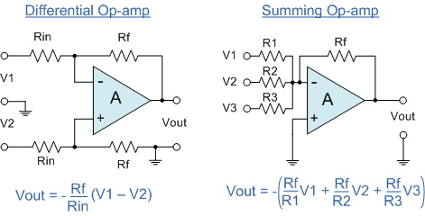
- Adding more input resistor to either the inverting or non-inverting inputs Voltage Adders or Summers can be made.
- Voltage follower op-amps can be added to the inputs of Differential amplifiers to produce high impeadance Instrumentation amplifiers.
- The Integrator Amplifier produces an output that is the mathematical operation of integration.
- The Differentiator Amplifier produces an output that is the mathematical operation of differentiation.
- Both the Integrator and Differentiator Amplifiers have a Resistor and Capacitor connected across the op-amp and are affected by its RC time constant.
- In their basic form, Differentiator Amplifiers suffer from Instability and Noise but additional components can be used to reduce the overall Closed-loop gain.

Differentiator and Integrator Op-amp Circuits
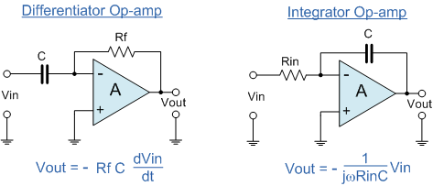
eCircuit Center

About SPICE | SPICE Basics | Running SPICE | CIRCUIT COLLECTION | SPICE Commands | SPICE Demos and Downloads
About Us | Contact Us | Home

Op Amp Input Offset Voltage
CIRCUIT
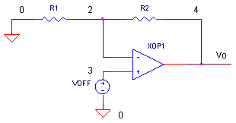
OP_VOFF.CIR Download the SPICE file
Build any opamp circuit, apply 0V to its input, and what do you expect at the output? Although you'd be tempted to say 0 V, there's actually an error voltage present at its output. What causes this error? You can trace the error back to a number of unbalances in the op amp's internal transistors and resistors. To account for this in a circuit design, the net error is modeled as an offset voltage, Voff, in series with op amp's input terminals. How will it affect your circuit? That depends on the op amp itself and your circuit design.

INPUT OFFSET VOLTAGE
The input offset voltage can range from microvolts to millivolts and can be either polarity. Generally speaking, bipolar op amps have lower offset voltages than JFET or CMOS types. The offset voltage is modeled in series with one of the op amp input terminals. Which one? Although the net effect is the same at either input, it's much easier to analyze Voff in series with the positive (V+) input. Why? The resulting circuit with Voff at V+ looks just like the non-inverting amplifier configuration. The analysis for this circuit is a simple one.

AMPLIFIER WITH OFFSET VOLTAGE
Ignoring Voff for a moment, is the circuit (shown above) an inverting or non-inverting amplifier? The answer is yes, both! With the input signal source set to 0 V ( shorted ), the inverting and non-inverting amplifiers look the same. The analysis for offset voltage is independent of the amplifier configuration. You can predict the error at the output Vo by the equation for the non-inverting amplifier
Vo_error = Voff ( R2 / R1 + 1 )
What danger is this equation warning you about? If you have a large signal gain in your circuit, the amplifier will increase the error Voff along with the signal.
CIRCUIT INSIGHT Run a simulation of OP_VOFF.CIR. Voltage source VOFF models the offset voltage, initially set to +1 mV. With R1 = 10k and R2 = 100 k, what is the error at the output V(4)? The output error gets bumped to a whopping 11 mV as predicted by the equation above. Choose a different gain and/or offset voltage. Run a simulation. Is the output error what you expected?

OFFSET VOLTAGE CANCELLATION
In some applications, the output offset may be unacceptable. So how do you get rid of this error? One solution involves canceling it using another voltage of the same magnitude and opposite polarity. But the exact magnitude and polarity of the offset is unknown! You'll need a range of values (using a potentiometer, for example) to cover your basis. The question is how to get the canceling voltage into the circuit? One simple way is via a resistor R3 to the op amp's negative input.
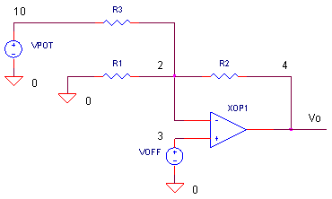
For simplicity, VPOT represents a voltage generated by a potentiometer divider circuit. The output due to VPOT is simply
Vo = VPOT ( -R2 /R3 )
which is the same equation as for the inverting amplifier.
HANDS-ON DESIGN Insert VPOT and R3 into the circuit by removing the * at the beginning of the statements. Run a simulation of OP_VOFF.CIR. Voltage VPOT generates a ramp that goes from -0.2V to +0.2 V. This simulates you turning the potentiometer over the full range. Check out the output voltage V(4). At some point, does the output get trimmed to 0 V?
Suppose you have a poorer grade op amp with a maximum offset of 5 mV. Change the VOFF value to 5MV. Run a new simulation. Does the output get trimmed to 0V? If not, increase VPOTs range beyond -0.2V to 0.2V. How big of a range to you need to cancel the 5mV offset. Another way you can adjust the cancellation range is to adjust R3. The equation above tells you that decreasing R3 increases the gain from VPOT to Vo.

HOW DOES R3 EFFECT GAIN?
What effect does R3 have on the gain of your circuit? That depends on which gain we're talking about. There are three gain of interest here. ( Notice that looking left from the op amps' negative input, R3 is effectively in parallel with R1.)
 | Input Offset Voltage Gain | Vo / Voff = R2 / (R1||R3) + 1 | R3 directly effects the output error - the smaller the R3, the larger the error due to Voff.
 | Non-Inverting Amplifier Gain | Vo / Vin = R2 / (R1||R3) + 1 | Feeding a signal to the op amp's positive input forms the non-inverting amplifier. The equation is identical to the one above.
 | Inverting Amplifier Gain | Vo / Vin = - R2 / R1 | Feeding a signal to the left leg of R1 forms the inverting amplifier. R3 has no effect on this gain.
CIRCUIT INSIGHT What are the above equations telling us? If you don't want your gain severely affected, keep R3 as large as possible. You can check the influence of R3 by setting VPOTs's ramp limits to 0V and 0V. Then, with R1 = 10k, R2 = 100k and VOFF = 1mV, the expected output error is 11 mV. Run a simulation to see how R3 = 1MEG or 100k changes the output voltage error?

OFFSET VOLTAGE DRIFT
Just because you trimmed out the offset voltage, doesn't mean all is tranquil on paradise island. The input offset voltage will drift with temperature; you have no control over this. But, knowing your overall error budget, you can select an op amp with a low enough offset drift for the intended temperature range.

INPUT BIAS CURRENT
Input offset voltage is not the only error of the op amp's input. The input stage is made of transistors, requiring a finite amount of bias current for operation. The circuit above assumes the bias is negligible. However, real op amps have bias currents to be reckoned with. The good news is there are clever techniques you can use to minimize and cancel out these errors too. (See Op Amp Input Bias Currents )

Op Amp Input Bias Current
CIRCUIT
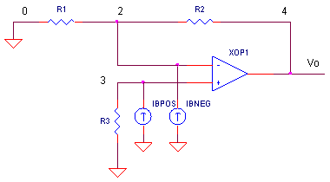
OP_IBIAS.CIR Download the SPICE file
One of the golden rules of op amp analysis says this: no current flows into either input terminal. This concept is key for analyzing an amplifier's signal gain. However, in reality, a small current flows into both inputs to bias the input transistors. Unfortunately, this bias current gets converted into a voltage by the circuit's local resistors and amplified right along with the signal. The result is an output error in your circuit. What can you do about it? A clever choice of resistor values can help you cancel most of the output error. The remaining error can be adjusted to zero if necessary.

INPUT BIAS CURRENT
Depending on the type of input transistor, the bias current can flow in or out of the input terminals. The input current is modeled as current sources, Ib+ and Ib-, in parallel with the positive and negative input terminals. How big is this current? The magnitudes can range from μA down to pA. Generally speaking, JFET or CMOS op amps have smaller bias currents than BJT types. Although Ib+ and Ib- are similar in magnitude, there not exactly the same. This difference, called the input offset current, is described by Iboff = Ib+ - Ib- .

AMPLIFIER WITH BIAS CURRENT
Is the circuit shown above an inverting or non-inverting amplifier? The answer is yes, both! With the input signal source set to 0 V ( shorted ), the inverting and non-inverting amplifiers look the same. What kind of undesirable voltage does the bias current create in your circuit?
Effect of Ib+ on Vo
Vo = Ib+ ∙ R3 ∙ ( R2 / R1 + 1 )
This is easy to understand. Ib+ flowing into R3 produces a voltage at the + input. Treating it like any other voltage at this terminal, the op amp amplifies it according to the non-inverting gain equation.
Effect of Ib- on Vo
Vo = - ( Ib- ∙ R2 )
Just like the transimpedance (current-to-voltage) amplifier, the output voltage is simply the input current times the feedback resistor.
What are the equations above telling us about resistor choice? For a given op amp, the smaller the resistor values, the smaller the errors. However, certain design goals, like low power, may force high resistor values. As usual, the end result is a compromise between competing design parameters.

CIRCUIT INSIGHT Run a simulation of OP_IBIAS.CIR. To look at the effect of Ib+ only, set the current sources to IBPOS = 100 nA and IBNEG = 0 nA. With R1 = 10k, R2 = 10 k and R3 = 10k, you'd expect to see an output error of 100 nA ∙ 10 k ∙ (10k/10k + 1 ) = +2 mV at V(4). Next, let's look at Ib- only. Set IBPOS = 0 nA and IBNEG = 100 nA. In this case you'd expect to see an output error of - 10k ∙ 100 nA = -1 mV.
Try scaling the resistors up and down to values like 100k or 1k. Run a new simulation. Do the errors scale along with the resistors? Also, notice that the errors for Ib+ and Ib- are opposite polarity! Maybe we can use this fact to make the errors from both currents cancel each other.

INPUT BIAS CANCELLATION
Currents Ib+ and Ib- create errors of opposite polarity. The question now is this: can we choose a magical value of R3 to force the errors caused by both bias currents to cancel each other? First, let's describe our goal mathematically. We would like the errors from both sources to be equal and opposite to one another. To do so, just take the two error equations above and set them equal to each other. Also, assume that the bias currents are equal Ib+ = Ib- = Ib.
Ib ∙ R3 ∙ ( R2 / R1 + 1 ) = Ib ∙ R2
Next, solve for R3 in terms of R1 and R2.
R3 = ( R2 ∙ R1 ) / ( R1 + R2 ) = R1 || R2
The solution is clear, choose R3 equal to the parallel combo of R1 and R2, and the bias current errors will cancel!
HANDS-ON DESIGN Set both IBPOS and IBNEG equal to 100nA. With R1=10k and R2=10k set R3 equal to R1 || R2 = 5k. Run a simulation of OP_IBIAS.CIR. Did your new choice of R3 reduce the output error at V(4) to 0V?

INPUT OFFSET CURRENT
Not to burst your bubble, but a clever choice of R3 doesn't mean all of the error is gone. In reality, the input currents are not exactly matched. They could differ by 10% or more. To see the effect of this offset, set IBPOS = 100nA and IBNEG = 90 nA. Run a simulation. How much residual error has popped up at V(4) due to the input offset current?

INPUT OFFSET CURRENT ADJUSTMENT
The output error due to the offset current may be too big for your application. So how do you get rid of it? You can plum in another voltage to cancel out the remaining error. Using a potentiometer VPOT and a resistor connected to the op amp's negative input does the trick. Check out this circuit from Op Amp Input Offset Voltage.

BIAS CURRENT DRIFT
Bias currents will drift as temperature changes. You have no control over this. But, knowing your overall error budget, you can select an op amp with a low enough bias current for the intended temperature range.
INPUT OFFSET VOLTAGE
Input bias current is not the only undesirable characteristic of the op amp's input. A number of unbalances in the op amp's internal transistors and resistors create an input offset voltage. You can predict the error at you circuit's output and adjust it to 0V if needed. (See Op Aamp Input Offset Voltage )

